Week – 6 GIT Hands-on
1. Git-HOL: Foundational Git & GitHub Operations
Objective
The objective of this hands-on was to understand the basic Git workflow by creating a local repository, tracking project files, committing changes, and publishing the repository to GitHub.
Summary of Actions
A new project folder named GitDemo-Handson1 was initialized as a Git repository using git init. The existing Git configuration was verified, and a welcome.txt file was created. The file was staged using git add and committed to the local repository using git commit.
After the local repository was ready, an empty GitHub repository named GitDemo-Handson1 was created. The local repository was connected to the remote repository using git remote add origin. Finally, the default branch was renamed to main, and the project was successfully uploaded to GitHub using git push -u origin main.

Screenshots
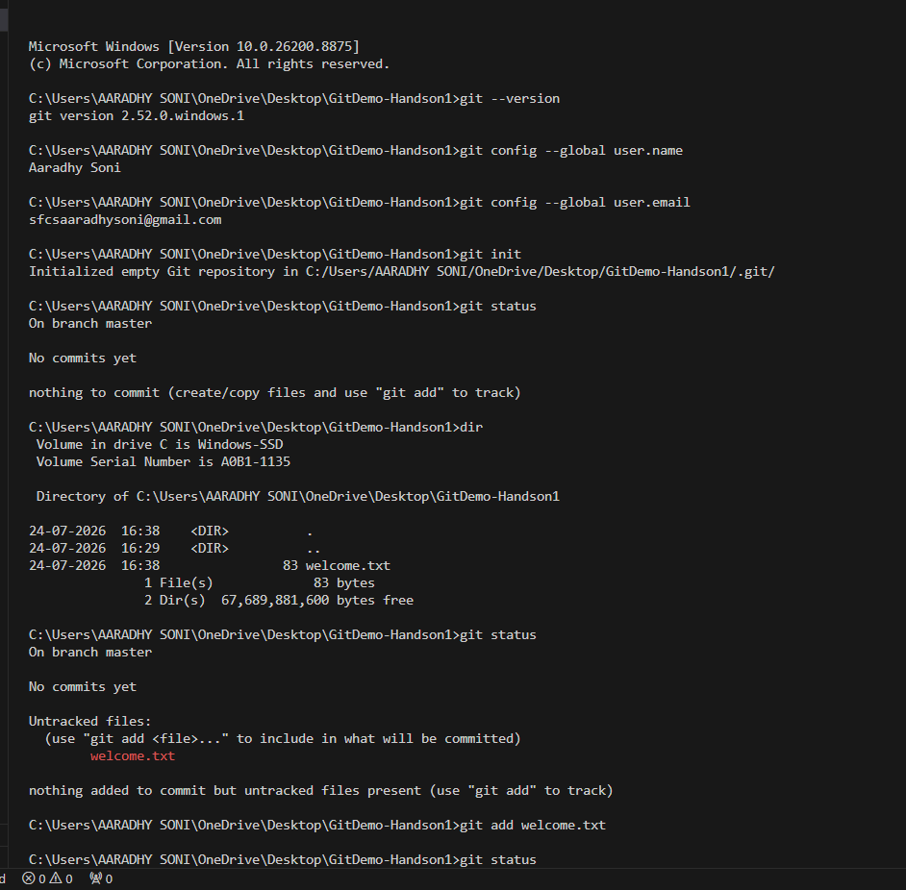
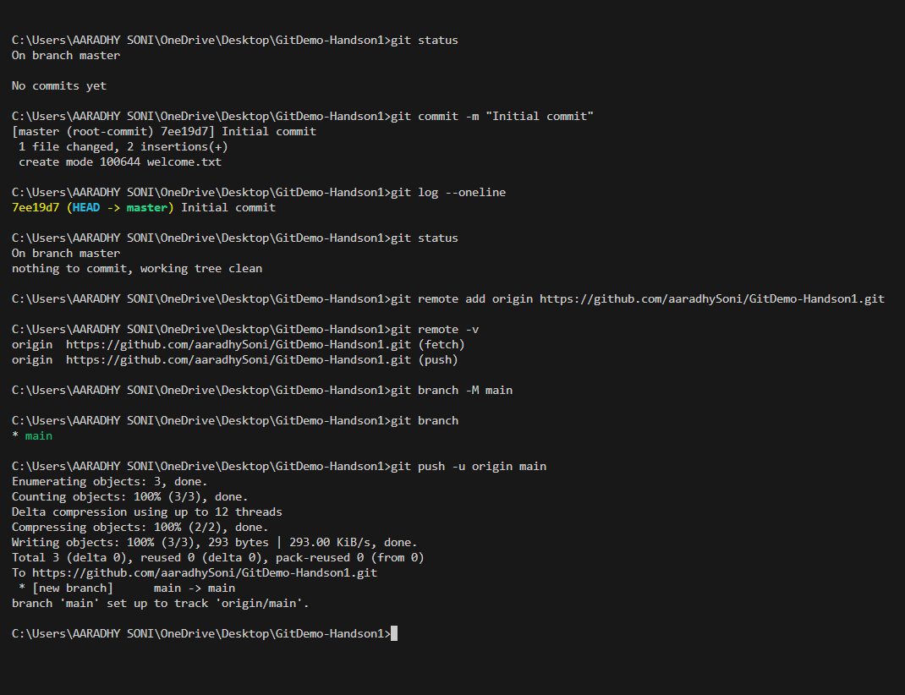 (This screenshot demonstrates the successful execution of the Git workflow, including repository initialization, file staging, commit creation, remote repository configuration, and pushing the project to GitHub.)

• GitHub Repository after Push
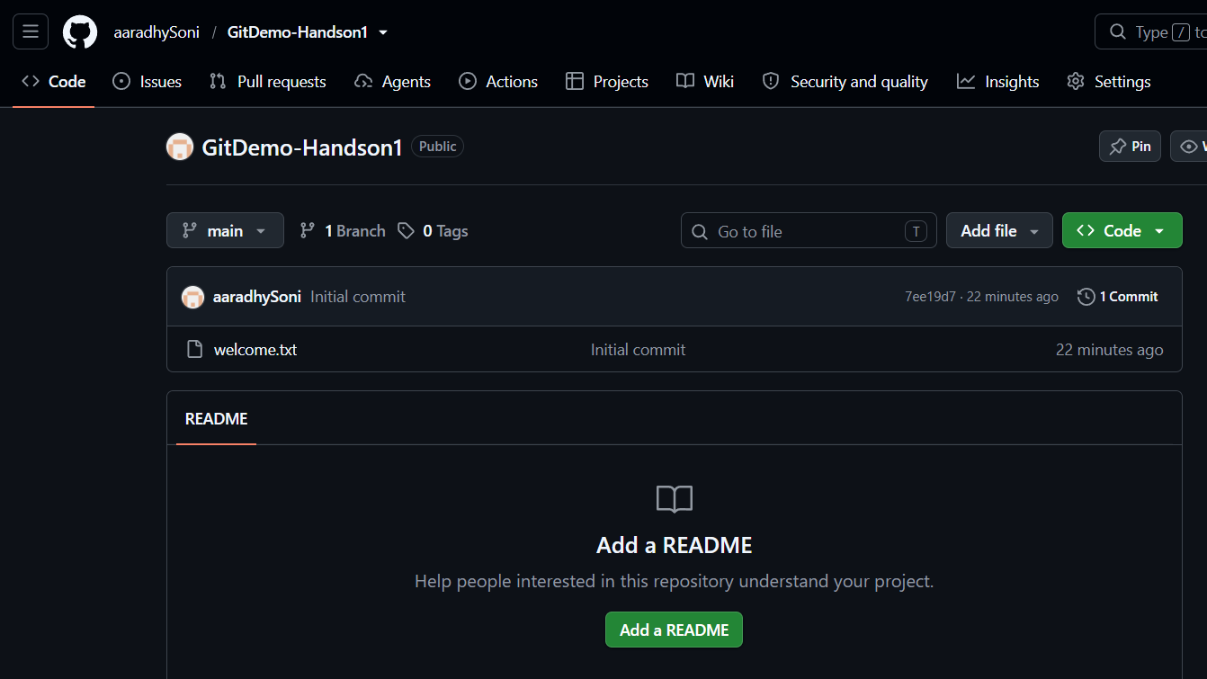
(This screenshot confirms that the local repository was successfully synchronized with GitHub and that the welcome.txt file and initial commit are available in the remote repository.)

2. Git-HOL: File Exclusion with .gitignore
Objective
This hands-on aimed to understand the purpose of the .gitignore file and learn how Git can be configured to ignore unnecessary files and folders from version control.
Summary of Actions
A sample log file (app.log) and a folder named logs containing a log file were created inside the project directory. A .gitignore file was then added to the root of the repository with rules to ignore all .log files and the logs directory.
The repository status was verified using git status, confirming that Git ignored the specified files and folders while tracking only the .gitignore file. Finally, the .gitignore file was committed and pushed to the remote GitHub repository.
Screenshots
• Terminal Output
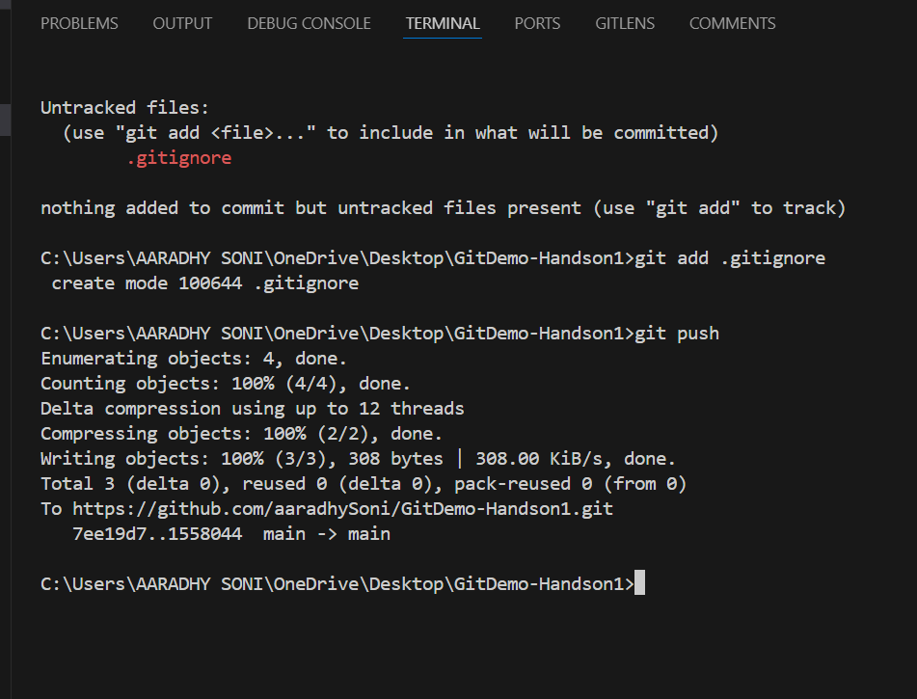 (This screenshot shows that Git successfully ignored the .log files and the logs directory while tracking only the .gitignore file.)

• GitHub Repository after Push
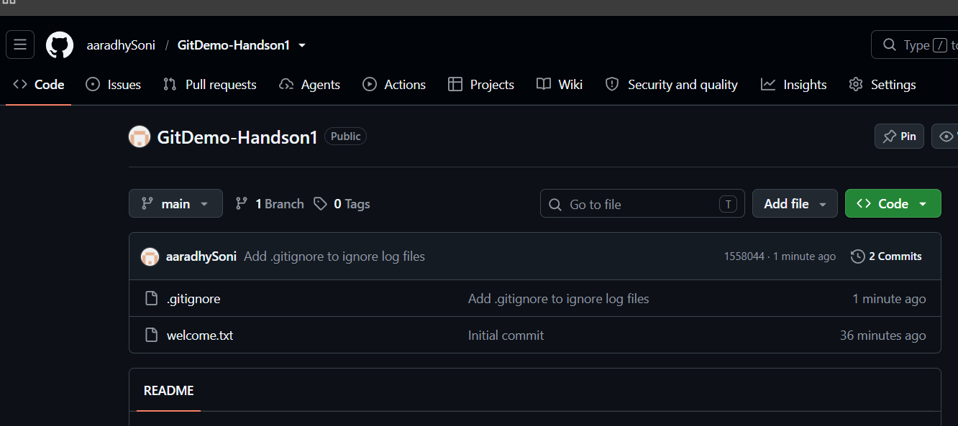
(This screenshot confirms that the .gitignore file was successfully committed to GitHub, while the ignored files and folders were excluded from the repository.)

3. Git-HOL: Branching and Merging
Objective
The objective of this hands-on was to understand the concept of Git branching and merging by creating a separate branch for development, committing changes independently, and merging those changes back into the main branch.
Summary of Actions
A new branch named GitNewBranch was created from the main branch. After switching to the new branch, a file named feature.txt was created, staged, and committed. The repository status was verified to ensure all changes were committed successfully.
The workflow then switched back to the main branch, where the changes from GitNewBranch were merged using the git merge command. The commit history was verified using git log --oneline --graph --decorate, and the merged branch was deleted using git branch -d. Finally, the updated repository was pushed to GitHub.

Screenshots
• Branch Creation and Commit
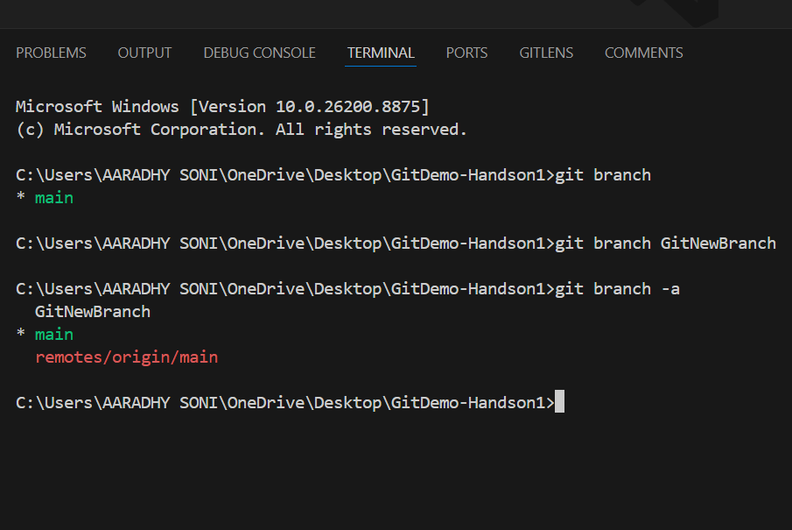
(This screenshot shows the creation of the feature branch, switching to it, adding a new file, and committing the changes.)

• Merge Operation and Repository History
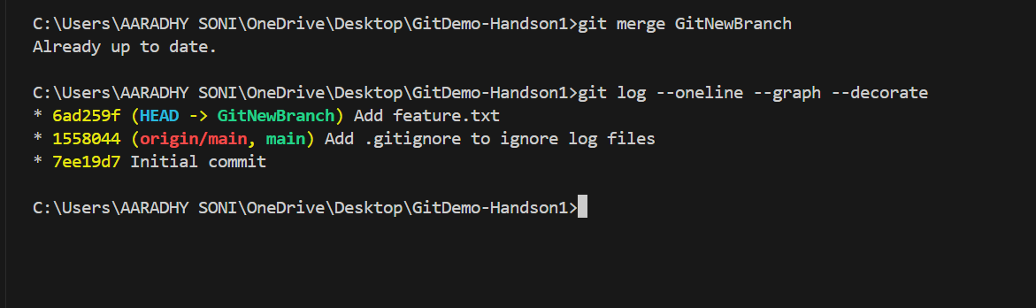 (This screenshot demonstrates the successful merge of GitNewBranch into the main branch and displays the commit history after merging.)

• GitHub Repository after Push
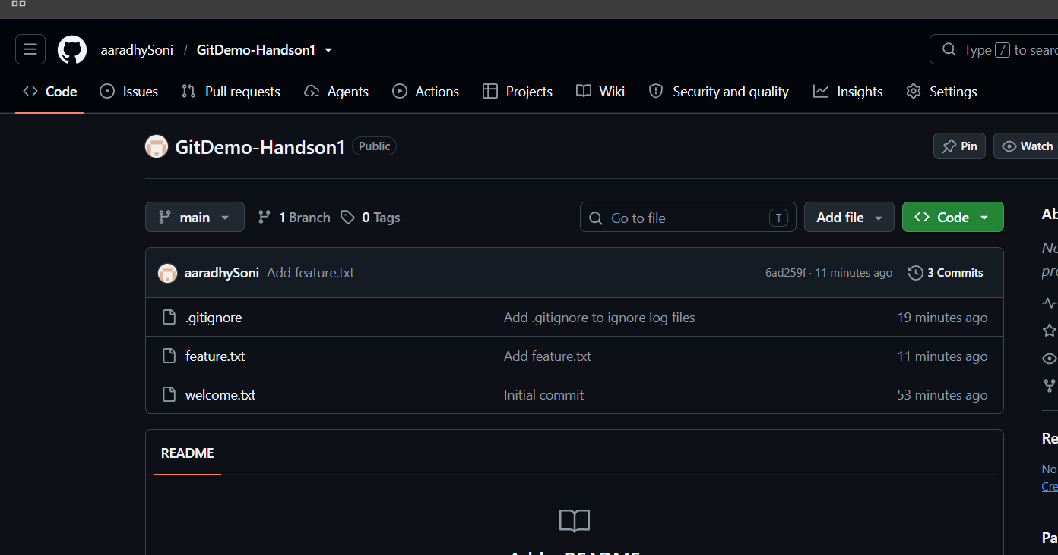
(This screenshot confirms that the merged changes were successfully synchronized with the remote GitHub repository.)

4. Git-HOL: Merge Conflict Resolution
Objective
The objective of this hands-on was to understand how merge conflicts occur in Git and learn the process of resolving conflicts when different branches modify the same file.
Summary of Actions
A new branch named GitWork was created, and a file named hello.xml was added with specific content. After committing the changes, the workflow switched back to the main branch, where another version of hello.xml with different content was created and committed.
While merging the GitWork branch into the main branch, Git detected a merge conflict because both branches contained different versions of the same file. The conflict was resolved manually using Visual Studio Code by editing the file and saving the required content. The resolved file was committed successfully. The .gitignore file was then updated to ignore backup files, and the merged branch was deleted before pushing the final changes to GitHub.

Screenshots
• Merge Conflict in VS Code
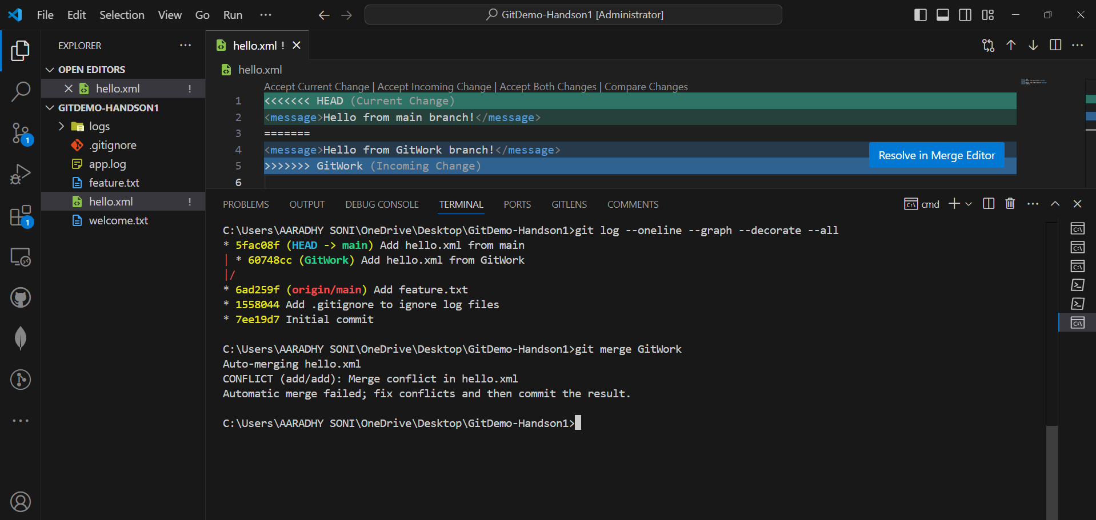 (This screenshot shows the merge conflict generated in hello.xml and the conflict markers displayed by Git during the merge process.)

• Final Repository History after Conflict Resolution
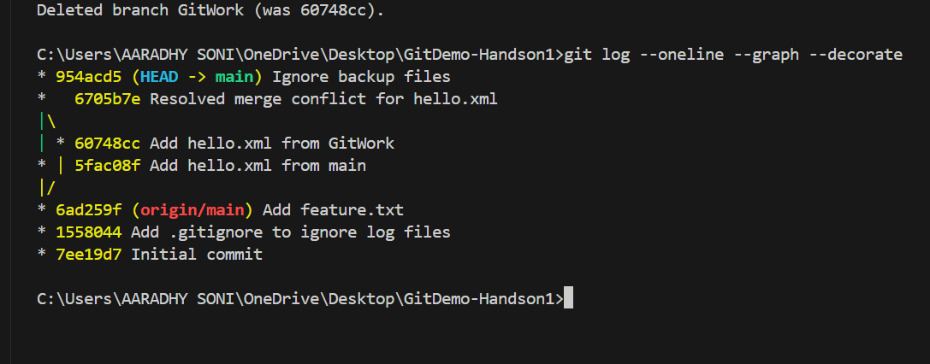 (This screenshot demonstrates the successful resolution of the merge conflict, deletion of the merged branch, and the updated commit history.)

• GitHub Repository after Push
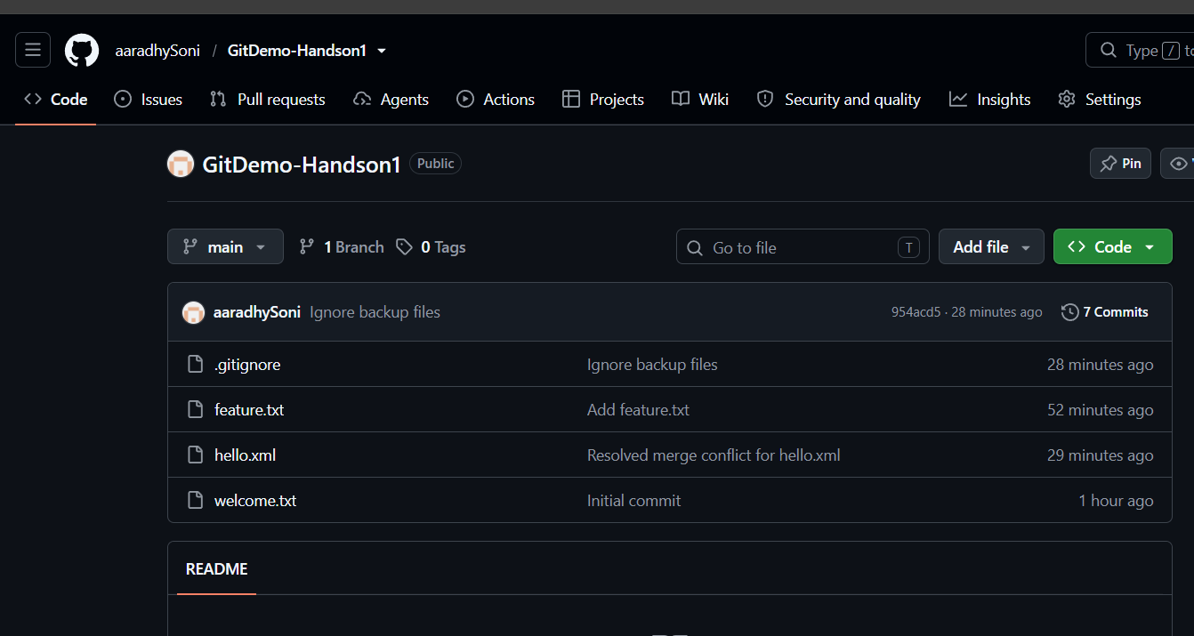 (This screenshot confirms that the resolved changes were successfully synchronized with the remote GitHub repository.)

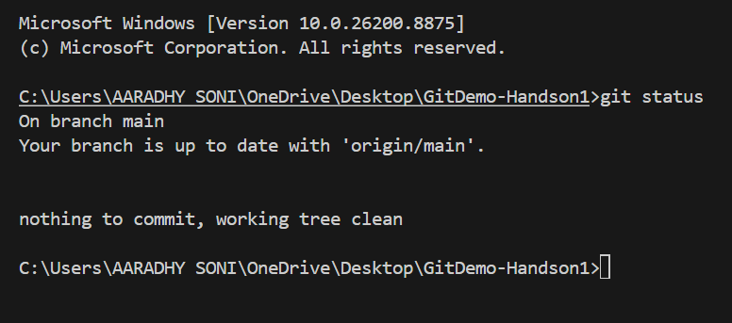

5. Git-HOL: Remote Repository Synchronization
Objective
The objective of this hands-on was to understand how to synchronize a local Git repository with a remote GitHub repository by verifying the repository status, pulling the latest changes, and pushing local commits.
Summary of Actions
The repository status was verified to ensure the working directory was clean and synchronized with the remote repository. The available local and remote branches were listed using Git commands. The latest updates from the remote repository were fetched using git pull origin main, confirming that the local repository was already up to date. Finally, git push origin main was executed to verify that all local commits had been successfully synchronized with GitHub. The remote repository was then reviewed to confirm that all project files and commit history were available.

Screenshots
• Terminal Output
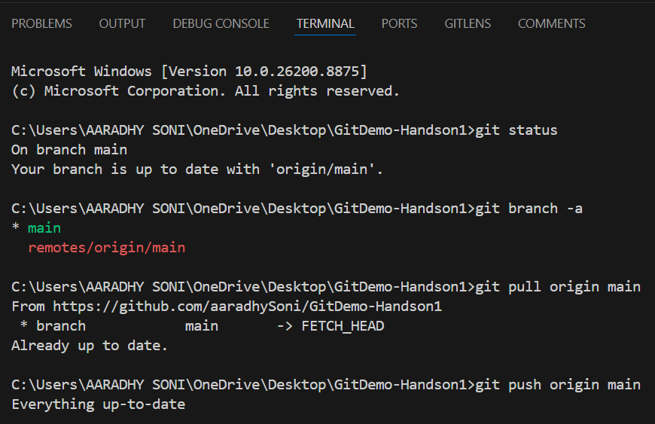
(This screenshot shows the successful execution of git status, git branch -a, git pull origin main, and git push origin main, confirming that the local and remote repositories are fully synchronized.)

• GitHub Repository after Synchronization
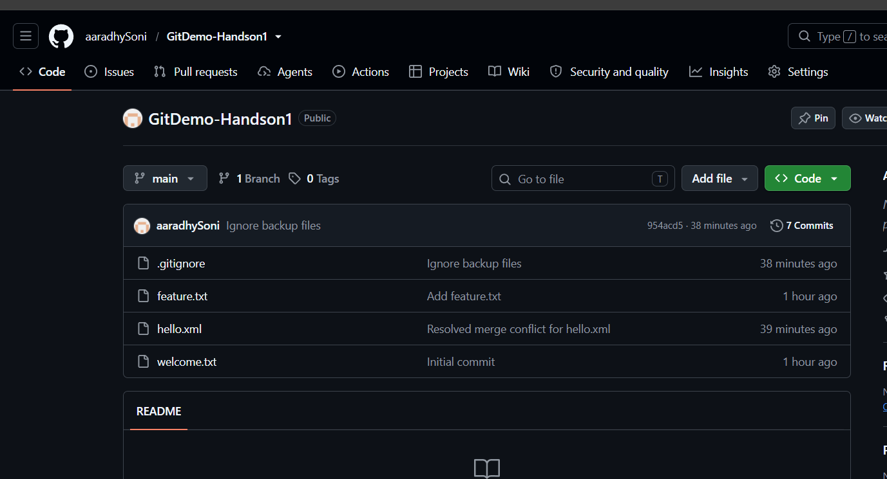 (This screenshot confirms that the GitHub repository contains the latest project files and commit history after successful synchronization.)

